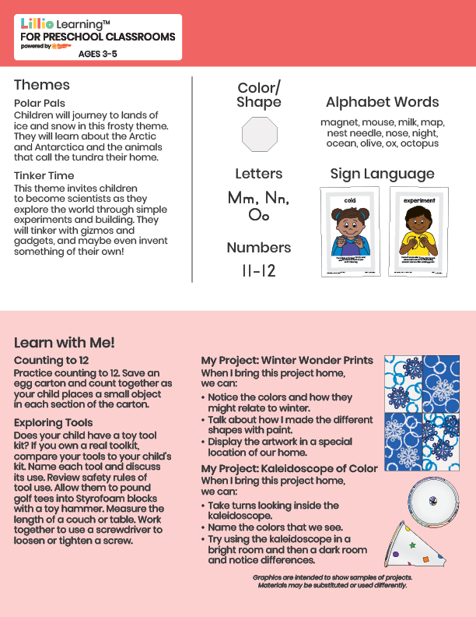
January 2026
Newsletter
Add Your Name/Logo Here

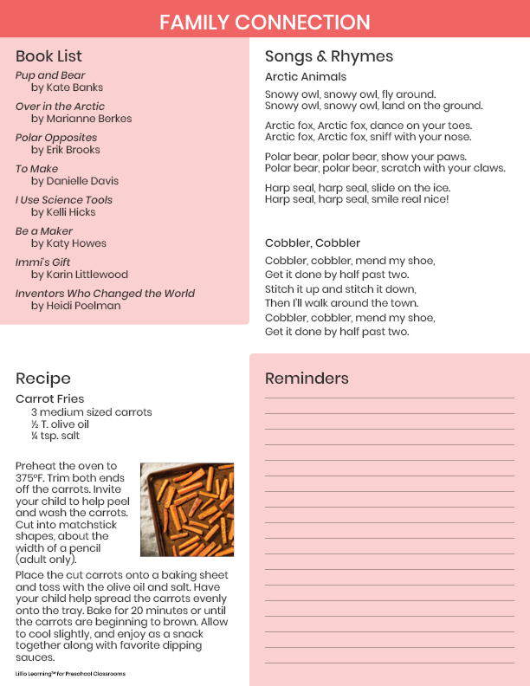

Add Notes

